**A car rental project within the field of database programming**

**Student name: Haytham Alsayyed**

**Id: 202110758**

**Supervisor: Dr. Alaa**

**T a b l e o f C o n t e n t s**

1. **Problem Statement**
2. **Functional and nonfunctional requirements**
3. **User Interfaces**
4. **Gannt chart**
5. **Use case diagram**
6. **Uml diagram**
7. **ER diagram**

**1. Problem Statement**

**Problem Statement**

**The existing car rental process lacks an efficient, user-friendly, and automated system to manage customer bookings, vehicle selection, rental terms, and additional services. Manual methods or outdated systems often lead to errors in price calculation, inefficient record-keeping, and poor customer experience.**

**Objective**

**To develop an automated Car Rental System with the following goals:**

**Enable secure user authentication through a login interface.**

**Allow users to select a car, specify rental terms, and add services (e.g., insurance, fuel).**

**Automatically calculate the total rental cost based on user input.**

**Provide a notes section for additional requests and confirm successful submission.**

**Improve efficiency, reduce manual errors, and enhance the overall customer experience.**

**2.1 Functional requirements**

**Functional Requirements\***

**1. User Authentication:**

**- Allow users to log in using a username, phone number, and password.**

**- Validate user credentials before granting access.**

**2. Car Selection:**

**- Provide options to choose a car type ( BMW, Mercedes, Hyundai, Toyota).**

**- Allow users to specify the rental term (number of days).**

**3. Price Calculation:**

**- Automatically calculate the total rental price based on car selection, rental term, and additional services.**

**4. Additional Services:**

**- Provide options for additional services such as:**

**- Full insurance.**

**- Gasoline filled.**

**5. Notes Submission:**

**- Allow users to input additional notes or special requests.**

**- Display a confirmation message upon successful note submission.**

**6. System Actions:**

**- Include functional buttons:**

**- Price: Display the calculated total price.**

**- Clear: Reset the form.**

**- Send: Submit the notes.**

**- Exit: Close the system.**

**7. Data Management:**

**- Save rental details, including car type, rental terms, and total price.**

**- Retrieve and display stored information when needed.**

**2.2** **Non-Functional Requirements**

**1. Performance:**

**- The system should calculate the total price and display confirmation messages within 1-2 seconds.**

**2. Usability:**

**- The interface should be simple, intuitive, and user-friendly for both technical and non-technical users.**

**3. Reliability:**

**- The system should ensure accurate calculations and display correct results consistently.**

**4. Security:**

**- User credentials (username, phone, and password) must be securely stored and validated.**

**- Prevent unauthorized access.**

**5. Scalability:**

**- The system should be capable of handling multiple users and an increasing number of car options.**

**6. Maintainability:**

**- The system should be easy to update for adding new car types or services.**

**7. Availability:**

**- The system should have high availability during operation, with minimal downtime.**

**8. Portability:**

**- The system should be deployable on various**

**platforms**

**3,** **User Interfaces**

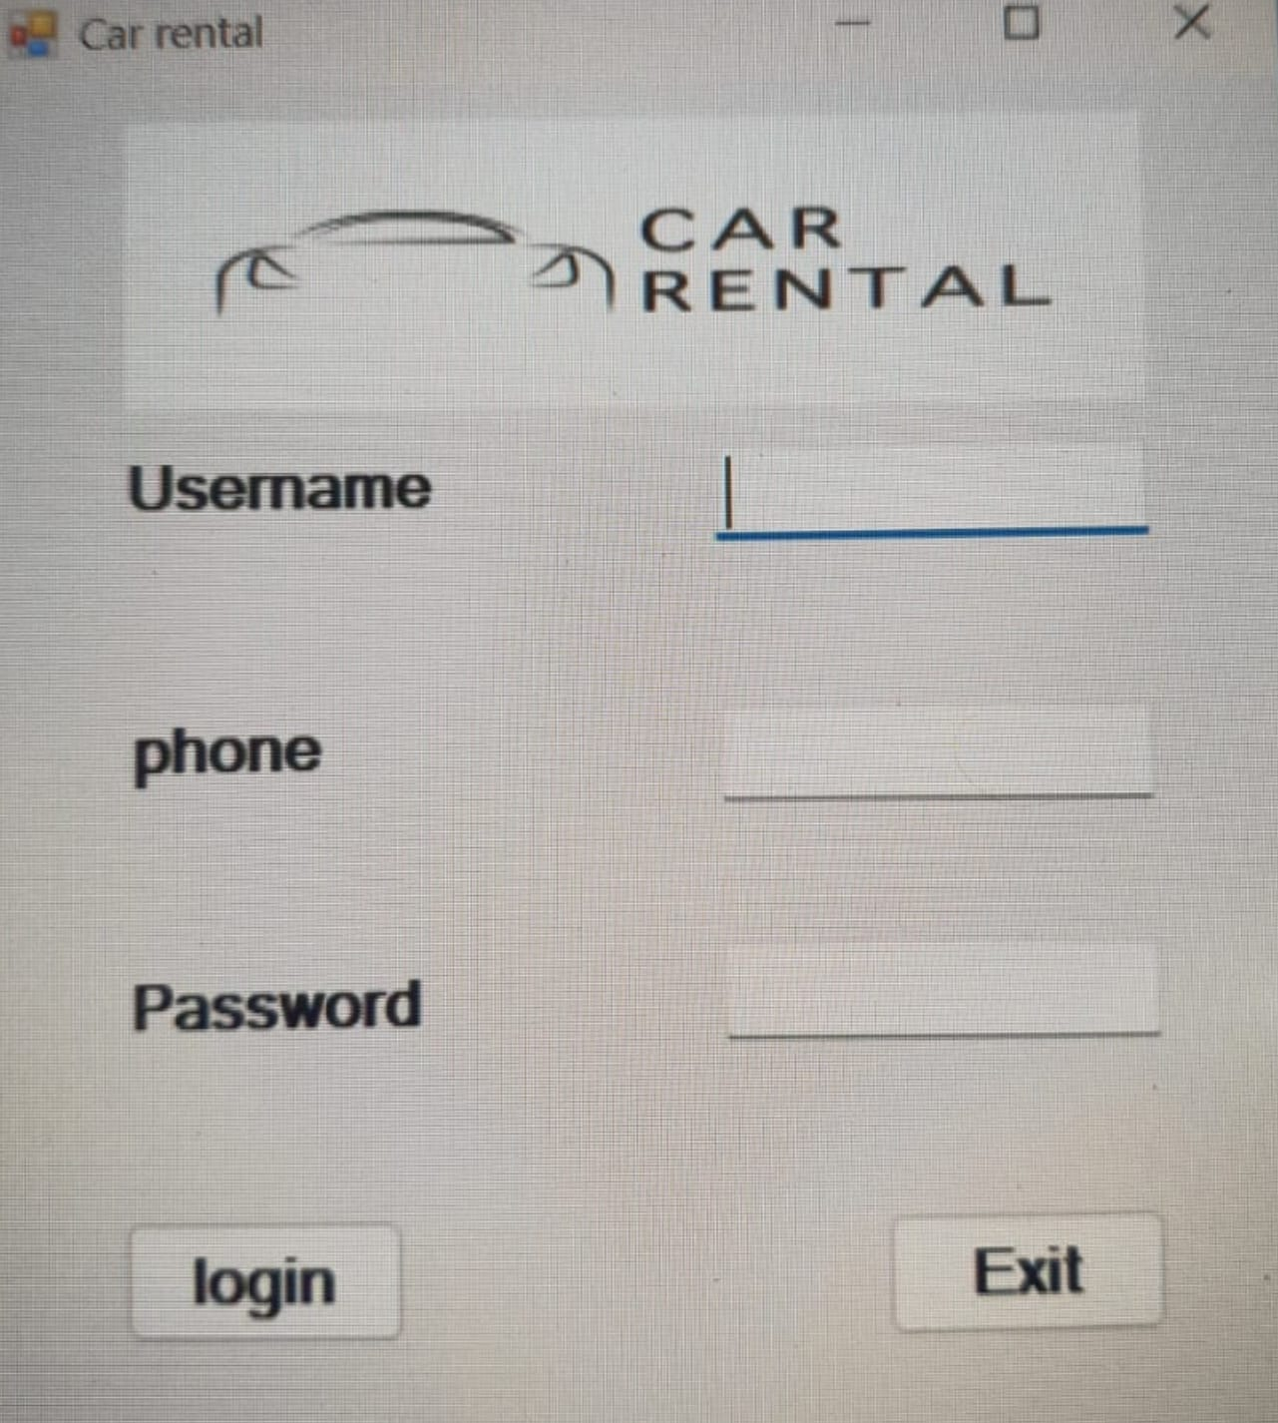

**The user can put his name, phone number and password**

**The user can choose the type and specifications of the car he wants and calculate the total value and other advantages**

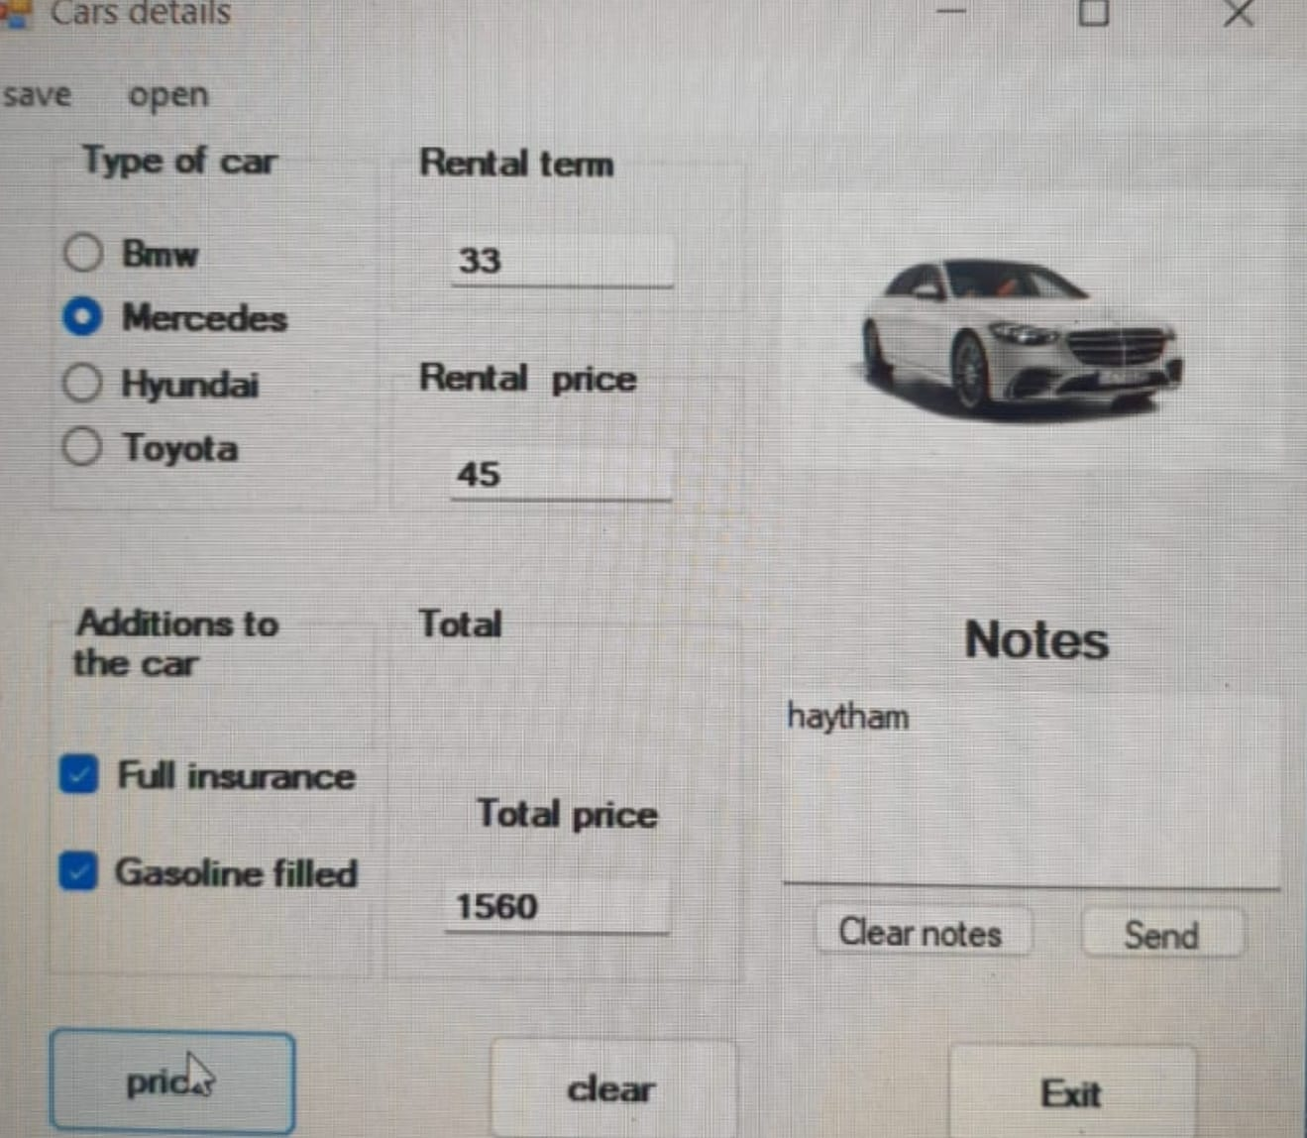

**.**



**The user can send feedback!**

**4.Gannt chart**

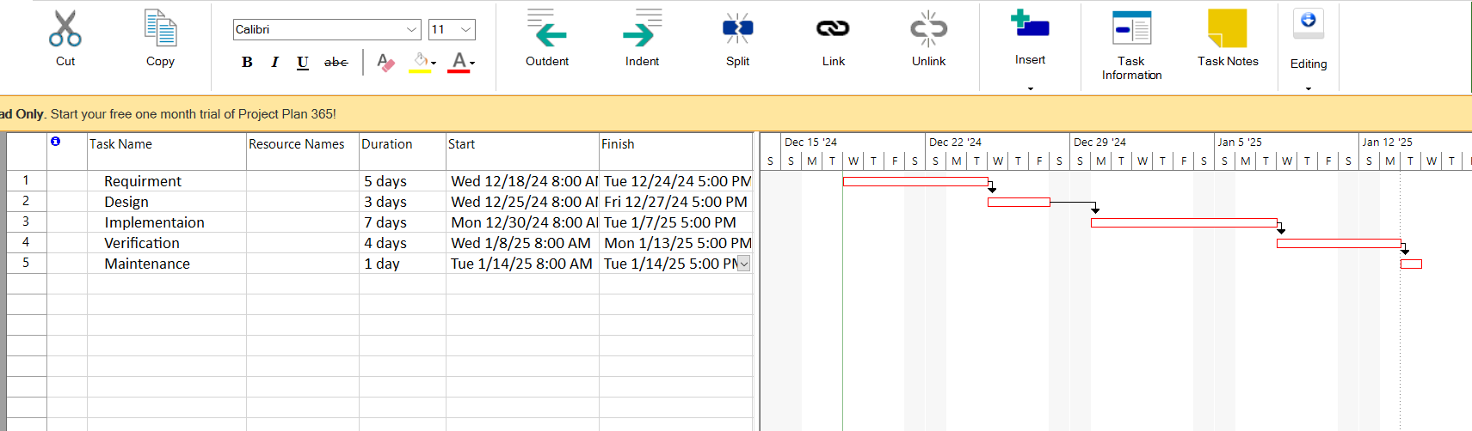

**The project plan was made in the waterfall system, where it shows when each task starts and ends as well as the sequence of tasks**

**5.Use case diagram**

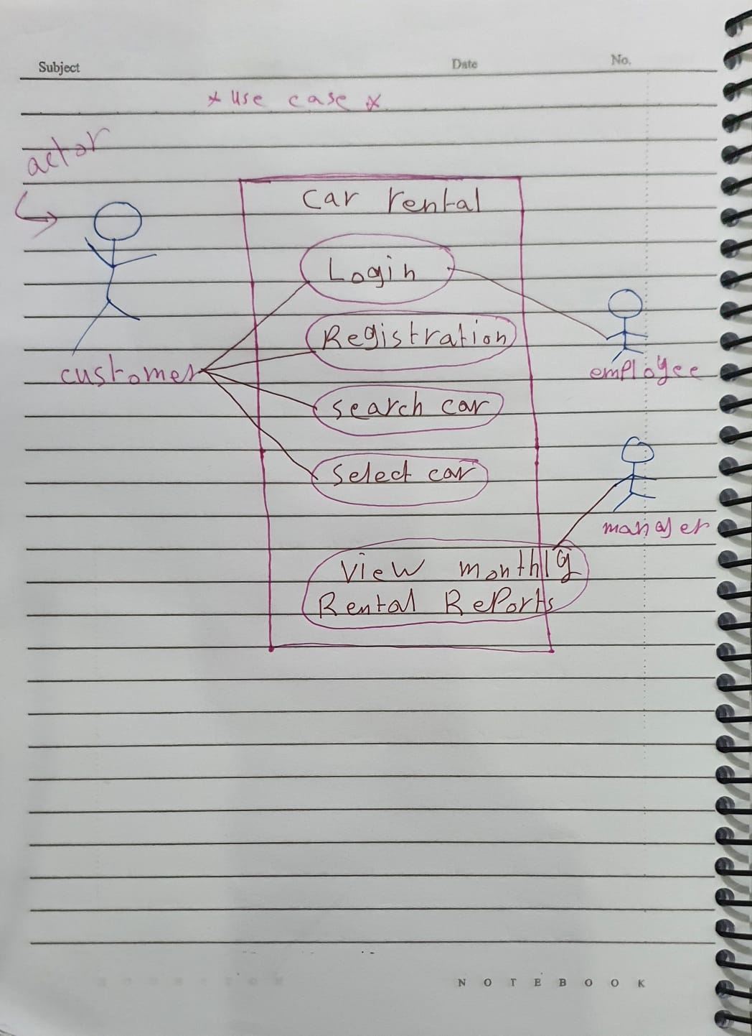

**6.Uml Class diagram**

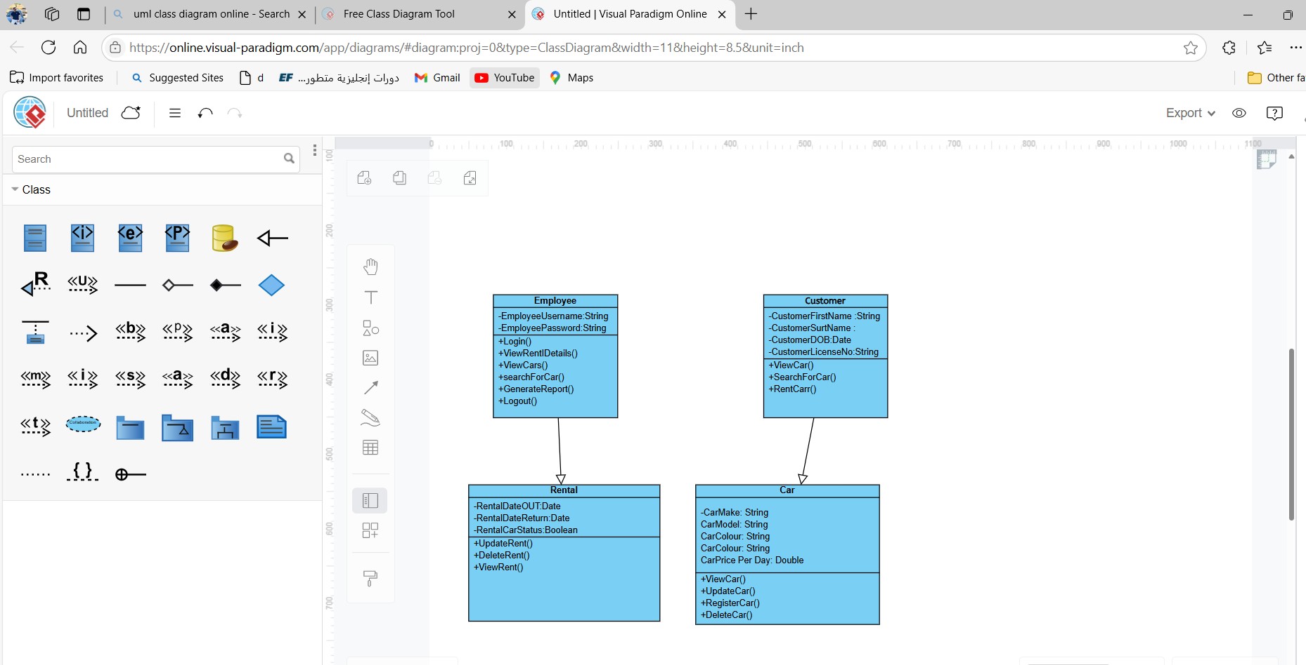

**7.ER diagram**

